MiSACWIS Project

CF54 – Find a Person UCR
Version 0.3

October 14, 2011

Prepared for:


120 N. Washington Square
SACWIS Project, 3rd Floor
Lansing, MI 48933

Prepared by:

Revision Log
Version | Date | A/D/C (Add, Delete, Change) | Author | Document Section # | Description
0.1 | 08/09/2011 |  | Pam Rasher |  | Initial version
0.2 | 10/13/2011 | A | David Somana | 2, 5 | Class diagram, CRUD matrix
0.3 | 10/14/2011 | C | David Somana | 2, 5 | Class diagram, CRUD matrix

Table of Contents
1 Introduction 5
1.1 Purpose 5
1.2 Scope 5
2 Class Diagram 6
3 Scenario Level Activity Diagram 7
4 Sequence Diagram 8
5 Business Data Dictionary 9
5.1 CRUD Matrix 9

List of Figures
Figure 1 – Class Diagram 6
Figure 2 – Activity Diagram 7
Figure 3 – Sequence diagram 8

- Introduction
  - Purpose
This Use Case describes the process for searching for a Person in MI SACWIS.
  - Scope
This function includes both a stand alone primary function that a user can access to find a person. It also includes how this use case can be accessed by other use cases as a sub function to that business process.
- Class Diagram
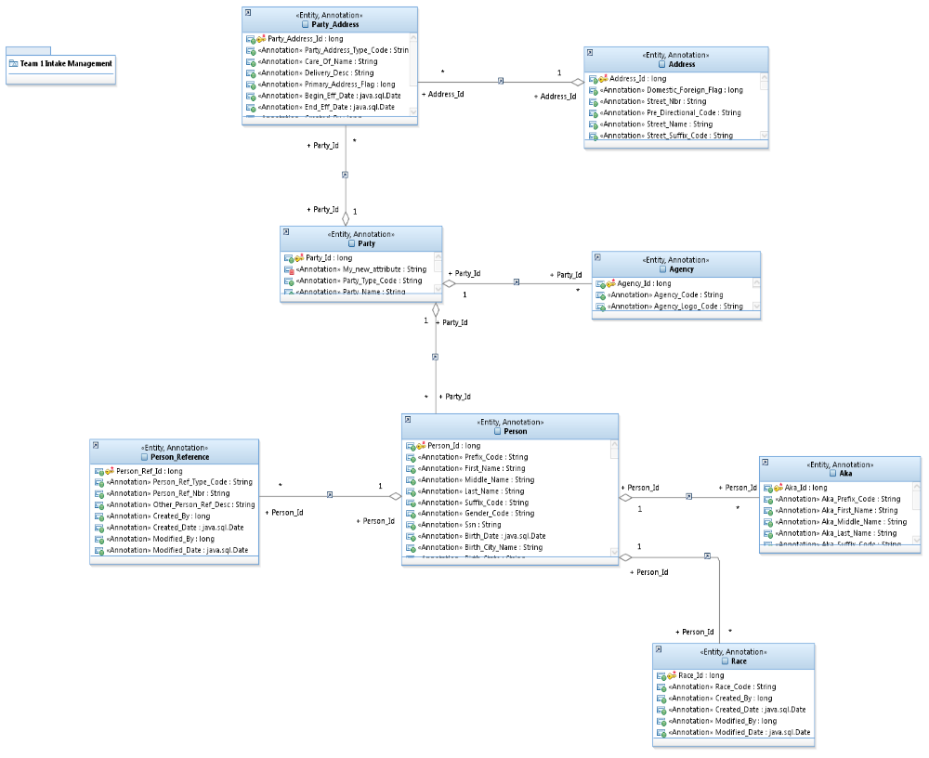
Figure 1 – Class Diagram
- Scenario Level Activity Diagram

Figure 2 – Activity Diagram
- Sequence Diagram
Figure 3 – Sequence diagram

Business Data Dictionary

CRUD Matrix
Class | Create | Read | Update | Delete
Person |  | X
PersonReference |  | X
Race |  | X
Aka |  | X
Party |  | X
Agency |  | X
PartyAddress |  | X
Address |  | X

